

Navigation aid for person with vision impairments

**Computer Science Project II**

By

Htoo Aung Hlaing

14 May 2018

Acknowledgements

I would like to express my very great appreciation to Dr. Lin Min Min Myint for his valuable and constructive suggestion during the planning and development of this senior project. His willingness to give his time so generously has been very much appreciated.

I would like to thanks others professors from School of Information Technology(SIU) for letting me do this work and believe in me to do this project.

Abstract

Vision is the most important part of human physiology as 83 percent of information being get from the environment is by the light. Navigation Aid for Person with Vision Impairment is about project that will help the blind people in the world to get a better access to the environments. This project provides alert system through vibration or the sound system by using cane, 1sheeld, Arduino programming, ultrasonic sensors and the vibration motors. Nowadays, when the blind person wants to goes out they prepared a guide dog, relatives, white cane or assistive technologies. This project is an assistive technology with consist of two ultrasonic sensors (above and the ground) mounted on the stick or a cane and a vibration motor with will also mounted on the stick. 1sheeld will mounted on the Arduino board for the navigation process for the used of GPS/GSM shield.

**Keywords:**  Arduino, ultrasonic sensor, blind navigation, microcontroller, 1sheeld.

Table of Contents

**Title Page**

Acknowledgements ii

Abstract iii

Table of Contents iv

List of Figures vi

Chapter 1 Introduction 7

1.1 Problem Statement 8

1.2 Objectives 8

1.3 Scope of the Study 9

1.4 Expected Benefits 9

1.5 Project Risks and Mitigation 9

Chapter 2 Literature Review 11

2.1 Voice Recognition and Voice Navigation for Blind 11

2.2 How to Make a Smart Cane for the Visually Impaired with Arduino? 12

2.3 RFID Information Grid for Blind Navigation and Way Finding 13

Chapter 3 Methodology 15

3.1 System Design 15

3.1.1 Hardware Description 16

3.2 Project Plan 19

3.2.1 System Workflow – Phase (1) 19

3.2.2 System Workflow – Phase (2) 20

3.3 Arduino Software (IDE) 21

Chapter 4 Implementing and Testing 23

4.1 Introduction 23

4.2 Implementation Techniques 23

4.2.1 Software Part: 23

4.2.2 Sensor Part: 23

4.2.3 Mobile Application: 23

4.2.4 Shield: 24

4.3 Difficulties 24

4.4 Test Plan and Results 24

Chapter 5 Summary, Conclusion and Future Work 26

References 27

Appendix 29

List of Figures

**Title Page**

Figure 1. Prototype Design of the System 11

Figure 2: Items Used for Smart Cane 13

Figure 3: Smart Cane 13

Figure 4 System Architecture 15

Figure 5 Ultrasonic Sensor HC-Sr04 16

Figure 6 Arduino UNO R3 17

Figure 7 1Sheeld(Arduino Shield) 18

Figure 8 Use of 1Sheeld 18

Figure 9 Flowchart Phase (1) 19

Figure 10 Flowchart Phase (2) 20

Figure 11 Arduino IDE 22

# Introduction

Vision is the most important part of human physiology as 83 percent of information being get from the environment is via the light. Good vision is a precious gift but unfortunately loss of vision is becoming common now a day [6]. According to the World Health Organization (WHO), there are about 39 million people who are blind and 246 have low vision in the world. Recent 2014 statistic made by WHO, shows that 82 percent of people living with blindness are aged 50 and above [5]. Blindness may result from a disease, injury or other conditions that limit vision and because of which blind people confront a number of challenges everyday.

The biggest problem for the blind people is travelling alone or lost confidence in the middle of the sighted people or crowded location due to their disability when trying to figure out their direction to get their destination. They need to be familiar with the environments to avoid the accident. Sometime they need to use so much of tools and technique to help them in their mobility. Some use a guide dogs which are trained specially for the blind people to help their mobility to guide their way and alert the blind person to avoid from the obstacles. However, the cost of the guide dog is very expensive and most of the blind people cannot effort for that price and these dogs are only suitable for limitation of the dog life may be around 5 to 7 years. Nowadays the technologies are become smarter and smarter so that some people use the smart cane which can provide preloaded maps, wireless charging and some others features. Because of its features used, that could be also very expensive.

When 5 students from the Helwan University invented invented and produce 1Sheeld in 2013, it was better to do such kind of works to be done with a short period of time. 1Sheeld is an additional board that can turn any smart phone like Android/iOS smartphones into a sensor or GPS in the real world. By using the 1Sheeld, cost become very low and reduce the item list that need to use in this kind of project. To use the features from the 1Sheeld, the Arduino board and the 1Sheeld board need to be mounted together and to activate the 1Sheeld, download the 1Sheeld application from the Play Store or Apple Store according to the choice of the inventor. The advantage of using 1Sheeld is that there is no more cost for the additional items.

## Problem Statement

The growth of the technologies is become higher and higher day by day, the tools and system that help blind people are become vary. The cost of the systems and cost are also raise. However, the tools and system are become smarter and smarter the traditional white cane is still the number one choice among blind people because of its cost is low. Even though there may be a lot of similar systems which are smarter than this system, their price is still high. One of the main problem of the virtual impaired people have very low income sometime no income. So that the white cane which will use Arduino and 1Sheeld will help them with low cost.

## Objectives

This project implements navigation aid allowing the vision impaired person to know how far the object by detecting with ultrasonic sensor and in case of emergency, they lost their way, by pressing the button and sent the location to their family. So that the vision impairments person can live their daily life easily and safe. By using Arduino and 1sheeld, the price may be lower than the same system currently out there.

## Scope of the Study

This project focuses on developing a blind navigation system which:

* Arduino Uno R3 controller will use.
* Two ultrasonic sensors are mounted on the white cane to detect the obstacles.
* Vibration motor will be mounted on the gripper of the white cane.
* Adaptive vibration alert to the blind using vibration motor according to the distance detected.
* By using 1sheeld and smartphone, the emergency feature is added. When the user lost his way or in case of emergency, the user can sent his location to his family or trusted person by pressing the button on the white cane.
* When 1sheeld and smart phone distance is out of Bluetooth range, the buzzer will buzz to letting know the user that Bluetooth connection is disconnected.

## Expected Benefits

1. To help the mobility of the blind people
2. Protect the blind people from the obstacles and the dangerous areas.
3. Because of its less cost, most of the blind people can be afford.

## Project Risks and Mitigation

At the beginning of this project, a few of risks were identified. The main thing is no proper knowledge of Arduino system, a lack of knowledge in developing based on the electronic parts. Including no prior knowledge of 1sheeld and how to makes multiple tasks works at the same time on Arduino.

To mitigate these risks a continuous research of how Arduino and 1sheeld works helps. To know how multiple tasks works, the study of some examples pre-installed on Arduino library and guidance was sought from Dr. Lin Min Min Myint to fix this problem.

# Literature Review

This chapter presents all the sources from international journals and projects related to this project. This chapter will be covering 3 different types of research about the blind navigation systems that are produced in long time back.

## Voice Recognition and Voice Navigation for Blind

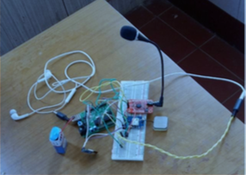

Figure . Prototype Design of the System

This system implements allowing to navigate the vision impaired person via voice recognition module and GPS module attached on Arduino board. User have to speak where he wants to go as an input to the voice recognition module. After that GPS module will process to get the user’s current location by getting latitude and longitude. GPS compares it with the destination’s latitude and longitude. The system will select the stored location from database to match the user’s input (assumed that the location were already stored in database).

The navigation directions are stored in the SD card in audio format. The blind person will then hear the directions stored in SD card with the help of head phone. The blind person receives the pronounced directions which he needs to follow to reach his destination.

This system is designed and devised to help the blind people to navigate safely and independently [6].

The disadvantage of this system is:

* Using multiple modules to set up.
* Not complete the design part.
* Cost is still higher.
* Only to the specific location can use the navigation feature.

## How to Make a Smart Cane for the Visually Impaired with Arduino?

In this system, there will be one ultrasonic sensor, Arduino uno and vibration motor. The ultrasonic sensor will detect the object distance from user and when it is close to the specific distance the vibration motor will vibrate to alert to the vision impaired person. This type of warning system is a good choice as it uses human sense of touch and therefore the fastest way to alert them. One best advantage of this system is using the cheapest items. The vibration motor used from the old phone.



Figure : Items Used for Smart Cane



Figure : Smart Cane

## RFID Information Grid for Blind Navigation and Way Finding

This system implements using the high frequency RFID tags to navigate the blind person. There tags will install under the floor of the building. In these tags the information of the location will be stored. RFID tags will be installed around the university environment such as along the outdoor pathways, in building, hallways and in the rooms. So that the blind person will know where he is by getting the information from the RFID tags. By using this tags, the system will no longer need for database or wireless systems.

One disadvantage of this system is that it can only useful all the function in limited area such as school, home and so on.

# Methodology

This chapter describes the proposed architecture for developing system. Important tools and techniques used in the development are also discussed.

## System Architecture

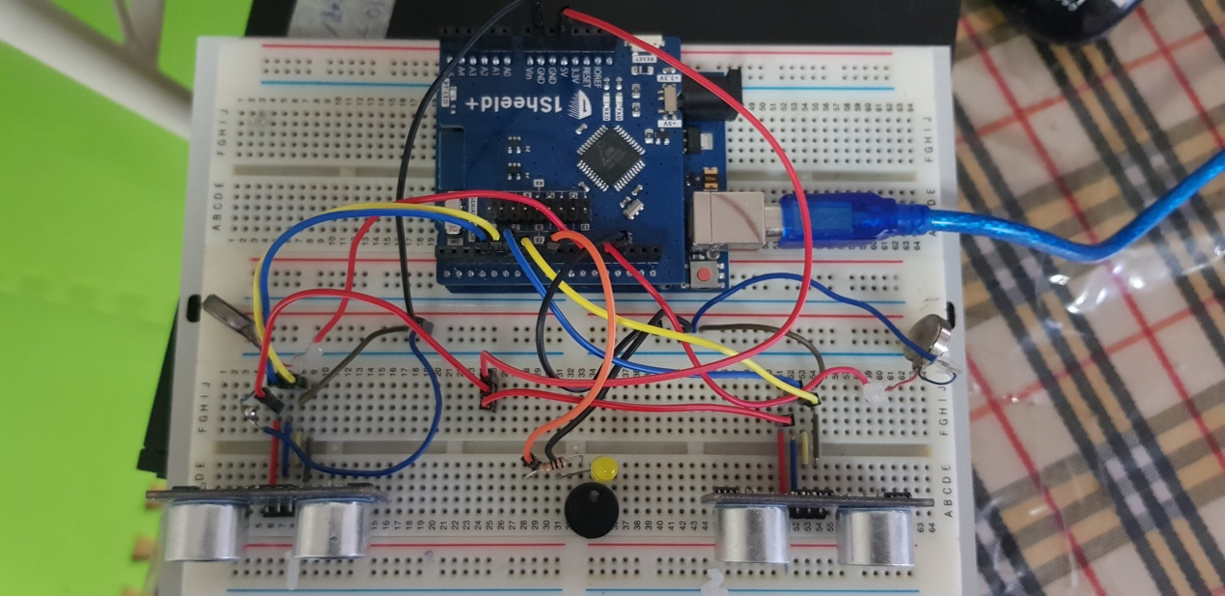

Figure System Architecture

In this system design, the blind person has to carry the white cane with him. The two ultrasonic sensor will be place on the stick such a way that in front one is in downward and another is in upward. When the obstacle will come in front of the blind person then the ultrasonic sensor sense the presence of the object after that Arduino will processed further and this system will alert to the blind by the adaptive vibration from the vibration motor. The system design will be as follow.

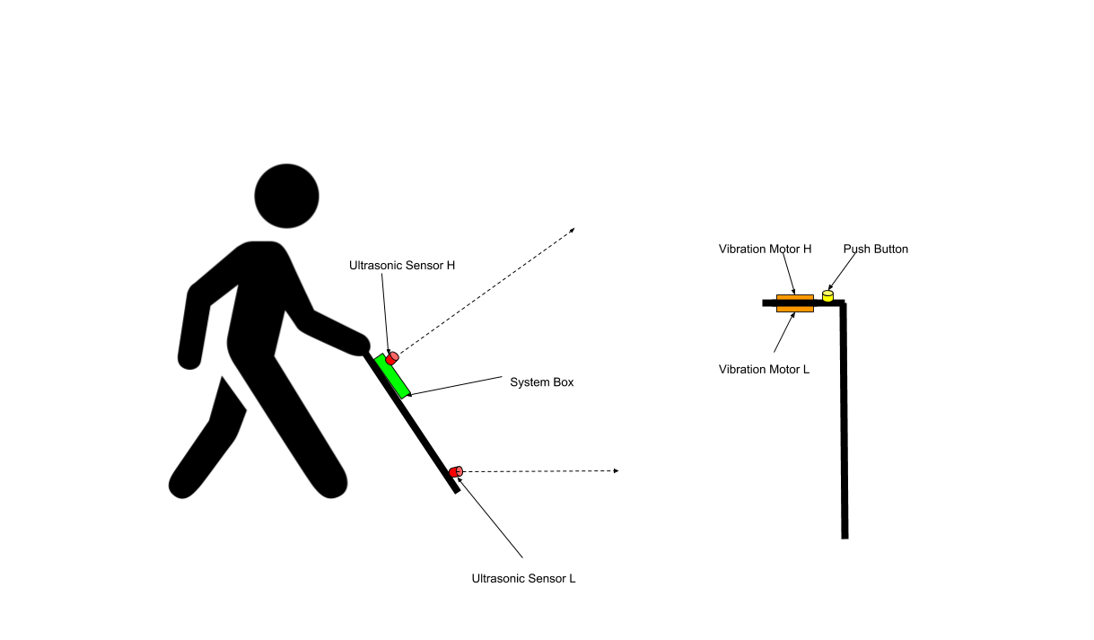

This stick having 1Sheeld device which have to mounted on the Arduino as a shield to use the GSM/GPS navigation module which is used to track the exact location of the blind and to check the user’s smartphone and the system is still connected via Bluetooth or not.

### Hardware Description

1. *Ultrasonic Sensors*

To detect the obstacles and avoid from them the ultrasonic sensor has to use. Ultrasonic ranging provides 2cm-400cm non-contact measurement function, the ranging accuracy can reach to 3mm. The ultrasonic sensor sends out a high-frequency sound pulse and then times how long it takes for the echo of the sound to reflect back.

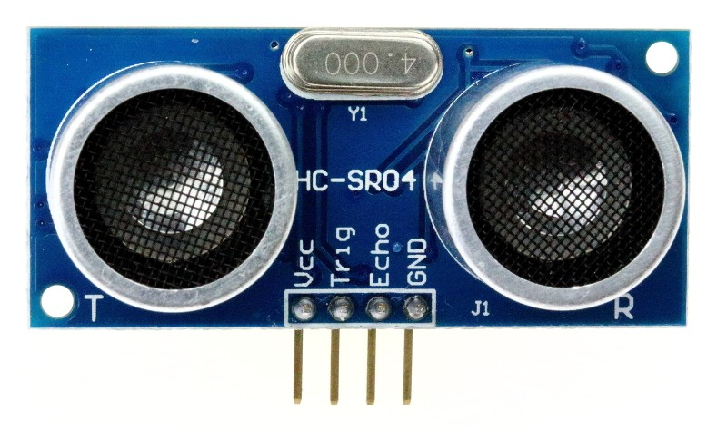

Figure Ultrasonic Sensor HC-Sr04

The sensor has 2 opening on its front. One opening transmits ultrasonic waves, the other receives them. In order to determine the distance to an object, it is necessary to implement a timing loop in the microcontroller code to measure the length of time required for the sound wave generated by the emitter to traverser the distance to the object.

1. *Arduino UNO R3*

Arduino is a single-board microcontroller, intended to make the application of interactive objects or environments more accessible. The hardware consists of an open-source hardware board designed around an 8-bit Atmel AVR microcontroller, or a 32-bit Atmel ARM. Current models feature a USV feature a USB interface, 6analog input pins, as well as 14 digital I/O pins which allows the user to attach various extension boards.

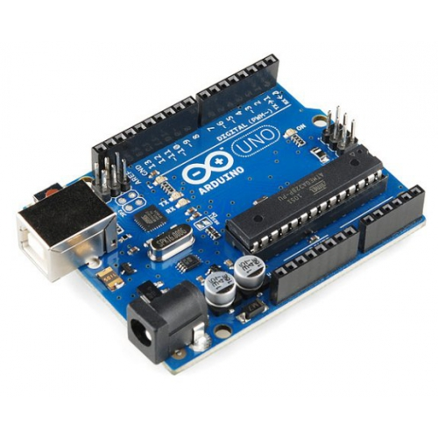

Figure Arduino UNO R3

It contains everything needed to support the microcontroller, simply connect it to a computer with USB cable or power it with a ac to dc adapter or battery to get started.

1. 1Sheeld

1sheed is a new configured shield for Arduino. It is connected to a mobile app that allow the usage of all of android smartphones capabilities such as LCD Screen, gyroscope, switches, LEDs, accelerometer, GSM, Wi-Fi, GPS and etc. into the Arduino Sketch.

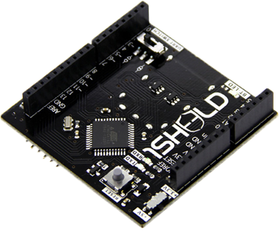

Figure 1Sheeld(Arduino Shield)

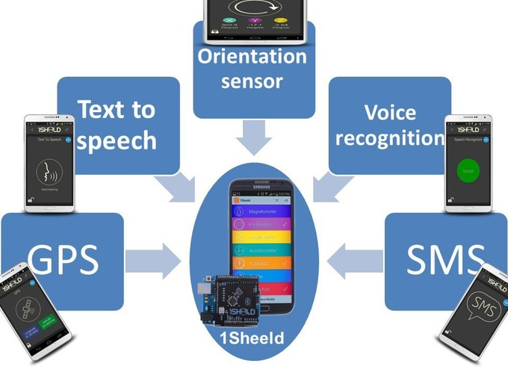

Figure Use of 1Sheeld

By using that 1Sheeld can act as input or output from the Arduino and make use of all of the sensors and peripherals already available on your smartphone instead of buying the actual shields.

1. *Vibration Motor*

The Vibration Motor is used in this project for getting adaptive feedback to vision impairments person.

1. *Battery*

To work the system, the whole day or limited hours, we need to use the battery (9V) to give the power to Arduino board and others parts that included in the system.

## Project Plan

### System Workflow – Phase (1)

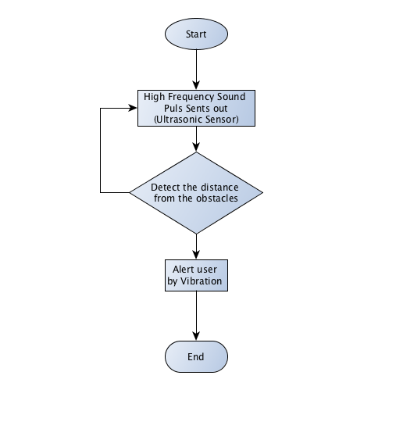

Figure Flowchart Phase (1)

As I have mentioned in the scope of the project in Chapter (1), the system development is divided into phase (1) and (2). The above system flows provide how the system will be going to work in the phase (1). As the blind person turn on the system, the ultrasonic sensor will perform the obstacle detection task. As mentioned above, the two ultrasonic sensors will be mounted in front of the stick which is in position of above and below. One from the above will detect the obstacles which are higher from the ground and another will be focus on the ground, which will detect the obstacles from the ground. The calculation task to calculate the distance from the blind person to the obstacles will be perform by the microcontroller. When the obstacles detect by the ultrasonic sensor, the vibration motor is going to vibrate to alert the user.

### System Workflow – Phase (2)

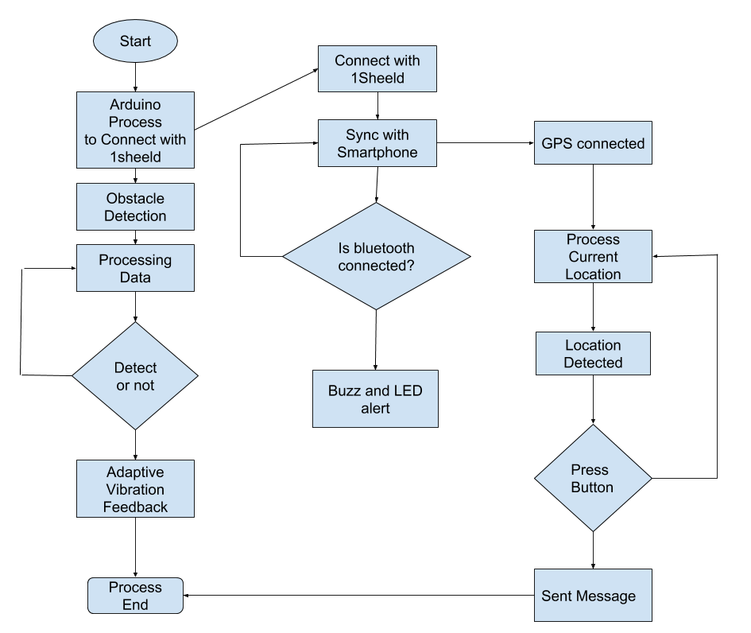

Figure Flowchart Phase (2)

Figure 10 trying to examine that the Phase (2) of the system, which will develop after the phase (1) is complete. In this phase, another module is added to the the system, which will perform the GPS navigation part by mounting the 1Sheeld device, which is the Arduino shield. 1Sheeld can perform as all in one shield which means that you don’t need to buy others Arduino shield. To perform the phase two, the user has to turn on the Android smartphone and sync with 1Sheeld. As it syncs with the system, it will detect the GPS signal by the smartphone. Once the GPS is connected, it will continuously perform to get the current location of the user. In case of emergency when the user presses the button which will be attach on the cane, 1Sheeld will re-perform to get the latest location of the user and sent that location to user’s family by SMS. One more feature is let user know that cane is still connected with smartphone or not. If not, the buzzer will buzz and LED will blink to let user know where is cane is or Bluetooth is still connected or not.

## Arduino Software (IDE)

Arduino is an open-source electronics platform based on easy-to-use hardware and software. Arduino boards are able to read inputs - light on a sensor, a finger on a button, or a Twitter message - and turn it into an output - activating a motor, turning on an LED, publishing something online. You can tell your board what to do by sending a set of instructions to the microcontroller on the board. To do so you use the Arduino programming language (based on Wiring), and the Arduino Software (IDE), based on Processing.

The Arduino Integrated Development Environment - or Arduino Software (IDE) - contains a text editor for writing code, a message area, a text console, a toolbar with buttons for common functions and a series of menus. It connects to the Arduino and Genuino hardware to upload programs and communicate with them.



Figure Arduino IDE

# Implementing and Testing

## Introduction

This chapter explain about the assembling process , working process and difficulties during the implementation.

## Implementation Techniques

Implementation of the navigation aid for vision impairments person comprise of sensor parts, mobile application, shield part and software parts as follow:

### Software Part:

* Programming language: C++
* IDE: Arduino IDE (Version- 1.8.5)

### Sensor Part:

* Two Ultrasonic Sensor

### Mobile Application:

* 1Sheeld Android Application

### Shield:

* SMS shield
* GPS shield

## Difficulties

**Managing the Delay to work multiple task in small amount of delay time**

The problem of managing delay is that to work multiple work at the same time on Arduino UNO is not much powerful to perform this task. When sensor one and two detect at the same time and need to vibrate to user at the same time is almost impossible so that one sensor has to wait to vibrate to another vibration.

To solve this problem, by studying the “BlinkWithoutDelay” and modified in the code by using the interval and Millis. Even though, this problem is cannot solved 100 percent but the delay between tasks is quiet less.

## Test Plan and Results

To get the deployment stage, the system was tested by feature by feature. According to the system, which include three main feature. After testing feature by feature, these three feature was integrated into one and manage the delay between them to work well. The testing plan as follow:

|  |  |  |  |
| --- | --- | --- | --- |
| Features | Test Case | Test Results | Success Rate by % |
| Single Sensor with  Vibration Feedback | Let sensor detect the distance and feed back by vibration motor. | OK | 100% |
| Multiple Sensor with Vibration Feedback | Let two sensor detect the distance and feed back by two vibration motor. | OK | 100% |
| Adaptive Vibration Feedback | Let vibration motor vibrate according to the distance detected. | OK | 100% |
| Emergency Feature | Press button and sent message to another mobile number. | OK | 100% |
| Alarm Feature | When smartphone and 1Sheeld is disconnected, user will get buzz alarm from buzzer. | OK | 100% |
| Deployment | Integrate all the above feature into Arduino again and manage between tasks. | OK | 90% |

# Summary, Conclusion and Future Work

To conclude, the navigation aid for vision impairments person is aim to help the blind person to avoid from possible dangerous situations by using the integrated features.

The two ultrasonic sensor attached will detect the distance from obstacles and feed back by adaptive vibration system. So that the user can know how much distance is between the obstacle and him. The push button attached on the cane can use when he is in emergency situation. When the user pressed that button the smartphone which is connected with 1Sheeld will sent to his/her family member phone number with his current location. The alarm feature will help the user when the user’s smartphone and 1sheeld is disconnected so that the user may know the Bluetooth connection is still connected or not. Not only that, this feature will let the user know when he is away from his cane, the alarm will buzz from the white cane.

# References

[1] Sharma, P., Shimi, S. L., Chatterji, S., *Design of Microcontroller based Virtual Eye for the Blind*, International Journal of Scientific Research Engineering & Technology (IJSRET), ISSN 2278 – 0882, Volume 3, Issue 8, November 2014

[2] Bansode, M., Jadhav, S., Kashyap, A., *Voice Recognition and Voice Navigation for Blind using GPS,* International Journal of Innovative Research in Electrical, Electronic, Instrumentation and Control Engineering Vol. 3, Issue 4, April 2015

[3] Nakita, S., T., Rohini, D., W., Shubhangi, V., K., *Sonic Eyes with Walking Stick for Blind People,* IJSRD - International Journal for Scientific Research & Development| Vol. 4, Issue 02, 2016

[4] Visual Impairment and Blindness, *http://www.who.int/mediacentre/factsheets/fs282/en/****,*** retrieved on 22, April 2017

[5] Bohem, K., What Problems do Blind People Face when Living life? *https://www.quora.com/What-problems-do-blind-people-face-when-living-life,* 8, November 2016

[6] Bansode, M., Jadhav, S., Kashyap, A., *Voice Recognition and Voice Navigation for Blind using GPS*, INTERNAITONAL JOURNAL OF INNOVATIVE IN ELETRICAL, ELECTRONICS, INSTRUMENTATION AND CONTROL ENGINEERING, Vol 3, Issue 4, April 2015

[7] Suhail, How to Make a Smart Cane for the Visually Impaired with Arduino, *https://diyhacking.com/arduino-smart-cane-for-the-blind,* retrieved on April 25, 2017

[8] Willis, S., *RFID Information Grid for Blind Navigation and Way Finding,* DOI: 10.1109/ISWC.2005.46 · Source: IEEE Xplore, on November, 2005

Appendix

Software Implementation

**#define CUSTOM_SETTINGS**

**#define INCLUDE_GPS_SHIELD**

**#define INCLUDE_SMS_SHIELD**

**#define INCLUDE_VIBRATION_SHIELD**

**#define INCLUDE_PUSH_BUTTON_SHIELD**

**#define INCLUDE_TERMINAL_SHIELD**

**#define INCLUDE_MIC_SHIELD**

**/* Include 1Sheeld library.*/**

**#include <OneSheeld.h>**

**#include <string.h>**

**// Define Pins for Sensor 1**

**#define trigPin1 4**

**#define echoPin1 5**

**//Define Pins for Sensor 2**

**#define trigPin2 6**

**#define echoPin2 7**

**// Define Pin for VibMotor 1**

**#define motorPin1 12**

**// Define Pin for VibMotor 2**

**#define motorPin2 13**

**/* Define a boolean flag. */**

**long UltraSensor, UltraSensorTwo;**

**unsigned long previousMillis = 0;**

**unsigned long interval = 250;**

**unsigned long previousMillisAlarm = 0;**

**unsigned long intervalAlarm = 3000;**

**boolean alarmReset = false;**

**float lat;**

**float lon;**

**String Message;**

**String Message1;**

**String Message2;**

**char latitude[10];**

**char longitude[10];**

**void setup()**

**{**

**/* Start communication.*/**

**OneSheeld.begin();**

**pinMode(trigPin1, OUTPUT);**

**pinMode(echoPin1, INPUT);**

**pinMode(trigPin2, OUTPUT);**

**pinMode(echoPin2, INPUT);**

**pinMode(motorPin1, OUTPUT);**

**pinMode(motorPin2, OUTPUT);**

**}**

**long SonarSensor(int trigPin, int echoPin)**

**{**

**digitalWrite(trigPin, LOW);**

**delayMicroseconds(2);**

**digitalWrite(trigPin, HIGH);**

**delayMicroseconds(10);**

**digitalWrite(trigPin, LOW);**

**long duration = pulseIn(echoPin, HIGH);**

**long distance = (duration / 2) / 29.1;**

**return distance;**

**}**

**void triggerSensor(int motorPin, long lSensorDistInCm, long lMaxDistInCm, char* sMsg)**

**{**

**int iTimeToDelayInMs = 100 * (lMaxDistInCm / lSensorDistInCm) * (lMaxDistInCm / lSensorDistInCm); // 60 cm -- 50 ms, 30 cm -- 200 ms**

**if (iTimeToDelayInMs > 1000) iTimeToDelayInMs = 1000;**

**if (lSensorDistInCm <= lMaxDistInCm) // cm**

**{**

**digitalWrite(motorPin, HIGH); // motor on**

**delay(iTimeToDelayInMs);**

**digitalWrite(motorPin, LOW); // motor off**

**delay(iTimeToDelayInMs);**

**}**

**else**

**{**

**digitalWrite(motorPin, LOW);**

**}**

**// Terminal.print(sMsg);**

**// Terminal.print(lDist);**

**// Terminal.print("cm, delay: ");**

**// Terminal.print(iTimeToDelayInMs);**

**// Terminal.println("ms.");**

**}**

**void SensorHandler() {**

**long lSensorDist1InCm = SonarSensor(trigPin1, echoPin1);**

**long lMaxDistInCm = 60;**

**triggerSensor(motorPin1, lSensorDist1InCm, lMaxDistInCm, "Sensor1: ");**

**long lSensorDist2InCm = SonarSensor(trigPin2, echoPin2);**

**lMaxDistInCm = 100;**

**triggerSensor(motorPin2, lSensorDist2InCm, lMaxDistInCm, "Sensor2: ");**

**}**

**void Alarm() {**

**int ledPin = 8;**

**int piezoPin = 8;**

**unsigned long currentMillisAlarm = millis();**

**if (currentMillisAlarm - previousMillisAlarm > intervalAlarm)**

**{**

**previousMillisAlarm = currentMillisAlarm;**

**if (OneSheeld.isAppConnected())**

**{**

**if (true)**

**{**

**digitalWrite(ledPin, LOW);**

**//tone(piezoPin, 0, 0);**

**alarmReset = true;**

**}**

**}**

**else {**

**digitalWrite(ledPin, HIGH);**

**tone(piezoPin, 12500, 500);**

**delay(1000);**

**alarmReset = false;**

**}**

**}**

**}**

**void loop()**

**{**

**unsigned long currentMillis = millis();**

**if (currentMillis - previousMillis > interval)**

**{**

**previousMillis = currentMillis;**

**SensorHandler();**

**}**

**if (PushButton.isPressed())**

**{**

**Terminal.println("Button Pressed");**

**lat = GPS.getLatitude();**

**lon = GPS.getLongitude();**

**Message1 = String(lat, 8);**

**Message2 = String(lon, 8);**

**Message = "I need Help! Google Maps - https://www.google.co.in/maps/place/" + Message1 + "," + Message2;**

**Terminal.print("Message Sent");**

**SMS.send("0846371854", Message);**

**}**

**Alarm();**

**}**